***Experiment 1.1***

**Student Name: Rahul Maurya UID: 20BCS7260**

**Branch: CSE Section/Group: 20BCS716/A**

**Semester: 4th Subject Code: 20CSP-253**

**Subject Name: Microprocessor and interfacing lab**

**1. Aim/Overview of the practical:** Addition of two 8bit numbers, sum 8 bit.

**3. Apparatus/Simulator used (For applied/experimental sciences/materials based labs):** Jubin simulator for 8085 microprocessor.

**4. Algorithm/Flowchart (For programming based labs):**

1. Load H-L pair with address 1000H.

2. Lower-order of 1000H.

3. Higher-order of 1000H.

4. Move the 1st operand from memory to reg. A.

5. Increment H-L pair.

6, Move the 2nd operand from memory to reg. B.

7. Initialize reg. C with 00H.

8. Immediate value 00H.

9. Add B with A.

10. Jump to address 000DH if there is no carry.

11. Lower-order of 000DH.

12. Higher-order of 000DH.

13. Increment reg. C.

14. Increment H-L pair.

15. Move the result from reg. A to memory.

16. Increment H-L pair.

17. Move carry from reg. C to memory.

18. Halt.

**5. Description/ Code:**

LXI H,1000H

MOV A,M

INX H

MOV B,M

MVI C,00H

ADD B

JNC 000D

INR C

INX H

MOV M,A

INX H

MOV M,C

HLT

#ORG 1000H

#DB 03h, 04h

**6. Result/Output/Writing Summary:**

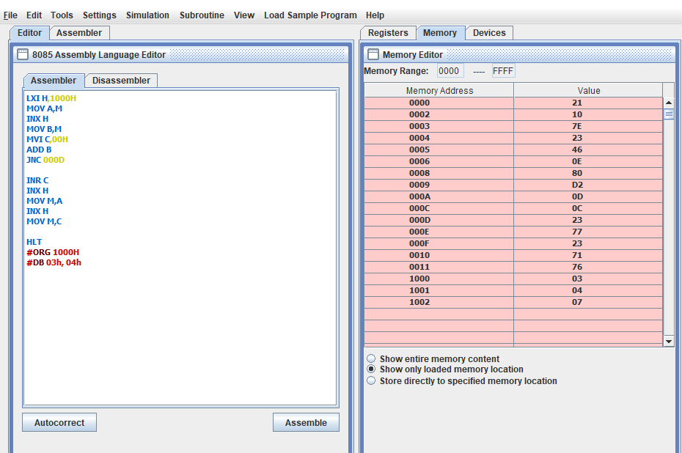

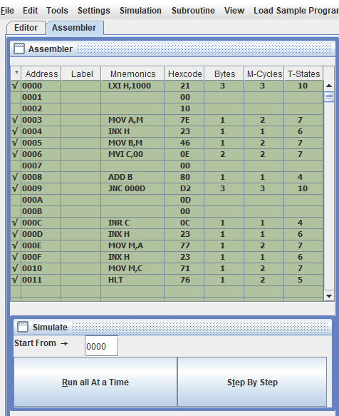

**Learning outcomes (What I have learnt):**

**1.** To use jubin simulator.

**2.** To add two 8-bit numbers on 8084 microprocessor.

**3.** To understand mnemonics

**Evaluation Grid (To be created as per the SOP and Assessment guidelines by the faculty):**

|  |  |  |  |
| --- | --- | --- | --- |
| Sr. No. | Parameters | Marks Obtained | Maximum Marks |
| 1. |  |  |  |
| 2. |  |  |  |
| 3. |  |  |  |
|  |  |  |  |